October 11, 2018

Howdy Dr. Roysam,

This spring you approved of our Makerspace and senior design project, Knuckles, the assistive robotic arm to be exhibited at the 2019 ECEDHA Conference in Tucson, Arizona. I’m glad to report that after our summer of research and study, we’ve begun our next phase of 3D-printing and ordering parts. We received the Intel RealSense D435 in early October and have started to learn how to use it with ROS, Robot Operating System. This week the ECE department was able to place most of the orders required to complete the build process of the arm. All other arm assembly components will be purchased in-person at Home Depot and reimbursed by the ECE department.

We are still discussing some current needs such as the Intel Voice Enabling Development Kit and a PC. But as they are required at later dates, we are going to seek company sponsorship to lower the overall cost to the department.

If all the arm parts are received and printed before the end of October, we will be on schedule to build and display the MOVEO BCN3D robot in-time for the IEEE Makers’ Showcase on November 9th. The robot should be able to be controlled with a physical controller for the event and controlled with ROS within the following weeks.

Thank you for your continued support of our research. If you have any questions or concerns, feel free to contact us.

Sincerely,

Andrew Blanchard

Matthew van Zuilekom

Rym Benchaabane

Paola Hernandez

**ADDIE Design Report**

**Fall 2018 – Spring 2019**

**Andrew Blanchard**

**Matthew van Zuilekom**

**Rym Benchaabane**

**Paola Hernandez**

**Purpose**

Knuckles is an assistive robotic arm that will hand the user requested objects and tools. It will serve as a convenient assistant that will increase the user’s productivity and decrease the risk of dexterity incidents.

**Overview Diagram**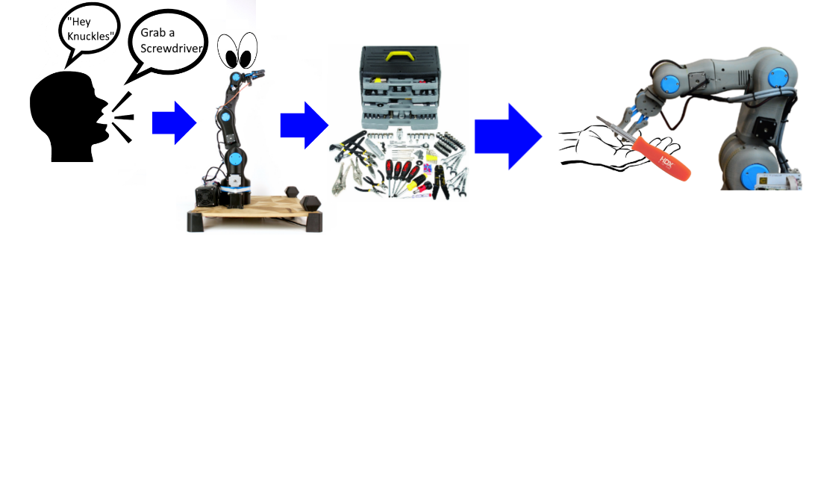

**Deliverables**

At the end of the Fall semester, our team will provide the hardware part of the project, which will be the physical robotic arm. The user will be able to use a developed simulation on the computer to manually control the robot through text commands. The simulation will be done through RViz on the Robotic Operating System (ROS). At the end of the Spring semester, our team will provide the software portion of Knuckles, which will include the object detection and voice recognition portion of the project. With the additional help of the software packages, the user will be able to give voice commands to receive requested objects from Knuckles.

**Design Considerations**

The mechanical properties of Knuckles are divided into two components, the arm and the gripper. The arm’s 5-axis movement and mechanics will be developed using ROS on Linux Ubuntu 16.04 LTS. We are connecting the arm’s joints with a total of 6 stepper motors (2 for the base). These motors will be processed by ROS and controlled by Arduino. Programming the ability to move autonomously allows the robot to decide how to move without external input beyond voice commands or manual input on ROS. The gripper is a three-finger design; each finger will have a set of tactile sensors to give the robot feedback on the pressure applied to the object it is attempting to grasp. The gripper will be controlled by a DC motor with an H-bridge. The gripper can therefore respond accordingly and autonomously adjust its grip with sensors. Once functioning in conjunction with the software components, it will be able to calculate and complete the best path to the item and its return path to the user. The robotic arm and the gripper will be 3D printed using an AutoCAD design. The design is inspired by the open source robotic arm BCN3D MOVEO (3D printed), with the gripper designed from an IEEE research paper.

For this project, we are programming in Python 3.5 and C programming. The two main software applications are visual and voice recognition.

The visual processing for Knuckles, including mapping and object recognition will be handled using OpenCV, RViz, and TensorFlow. Knuckles will utilize the Intel RealSense Depth Camera D435 using the mentioned software packages in ROS. OpenCV analyzes the video feed to detect, identify, and log the location of objects as the room is mapped. The recognition features will be executed through TensorFlow. RViz is our 3D visualization application for ROS that will work with the Intel Camera. These libraries will allow us to access and process images, while training with TensorFlow and improving the visual recognition. The user will activate Knuckles with a voice command which will begin the mapping of its surroundings and the execution of the command.

The robot will be able to receive voice commands to perform actions such as handing objects including phones, pencils, etc. The microphone will be incorporated with an Intel Speech Enabling Developer Kit. This add-on module is designed to fit the Raspberry Pi3 board. The Raspberry Pi3+ sends the audio to the Amazon Alexa Voice Service and receives the text request to be processed using a listening script connected to ROS. The command will be translated into the object data detected from the map created via RViz. The robot’s arm motors will move and execute the motion command. A voice command will be used to “wake-up” Knuckles from its standby state, which then allows Knuckles to execute commands.

Our main design constraint is the time allotted to develop a gripper that’s capable of grabbing a larger range of objects.

**Target Objective and Goal Analysis**

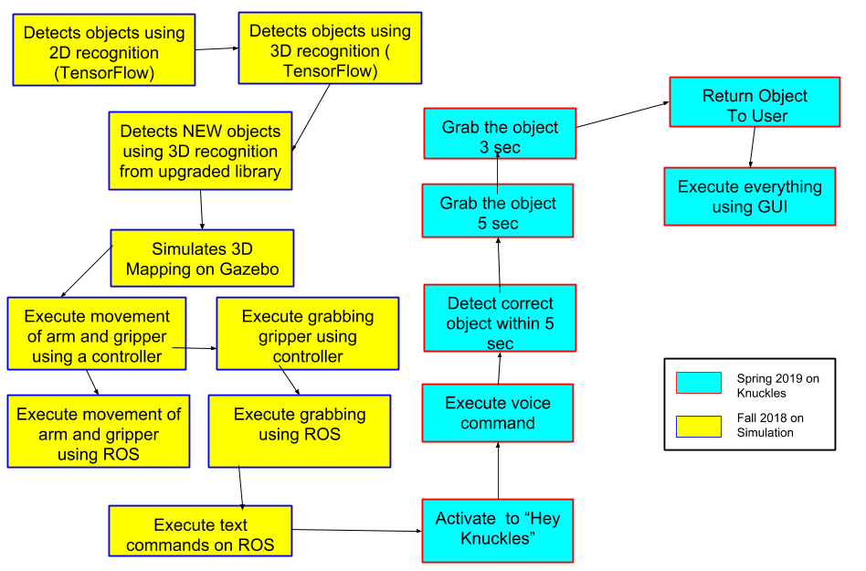

**Test Plan**

1. Tests the mobility of the robot: Verifies the arm and gripper motion with a controller.
2. Test robot connection to ROS: Request the robot to position itself in straight up, straight out, and in reaching motions.
3. Test object recognition: Validate that can recognize multiple objects at the same time.
4. Test the ability of the robot to map the environment: Compare map data representation to that of the workspace of the robot.
5. Test the combination of visual recognitions: Measure and compare the accuracy of object tags in ROS and in real space.
6. Test the search function: Use text recognition to have the robot point at objects.
7. Test the retrieval function: Use text recognition to retrieve an object.
8. Tests the voice recognition: Compare voice commands to the text in the ROS terminal.
9. Test the user search function: Upon voice request, have the robot find the user.
10. Test the return function: Have the robot drop the object as close to the user as possible.
11. Test the gripper with the return: Have the robot wait until the user is within range and pulls on the object.
12. Test the timing of the entire process: Have the robot time to complete function.

**Budget**

*Table 1:List of MOVEO BCN3D parts, associated cost/unit, and status of each order*

|  |  |  |  |  |
| --- | --- | --- | --- | --- |
| **BOM ID** | **Part** | **Quantity** | **Single Price** | **Status** |
| **1** | Stepper Motor SM42HT47 | 1 | 23.22 | Ordered |
| **2** | ARDUINO MEGA 2560 | 1 | 14.86 | Ordered |
| **3** | Stepper Driver TB6560 | 6 | 43.99 | Ordered |
| **4** | Power Supply 24 [V], 320[W] | 1 | 72.89 | Ordered |
| **5** | RAMPS V1.4 | 1 | 12.50 | Ordered |
| **6** | Power Converter 24[V] to 12[V] | 1 | 41.94 | Ordered |
| **7** | Servo Motor 180 55G | 1 | 29.00 | Ordered |
| **8** | Gear Ratio 5:1 Planetary Gearbox  Nema 17 Stepper | 1 | 42.00 | Ordered |
| **9** | Nema 23 flat shaft | 2 | 45.50 | Ordered |
| **10** | Nema 14 36 [mm] | 1 | 19.99 | Ordered |
| **11** | Nema 17 | 1 | 12.99 | Ordered |
| **12** | Chrome steel smooth bar-134[mm] | 3 | 4.29 | Verified |
| **13** | Chrome steel smooth bar-114[mm] | 1 | 0.00 | Verified |
| **14** | Chrome steel smooth bar-80[mm] | 1 | 0.00 | Verified |
| **15** | Ball Bearing 608ZZ 8[mm] x 22[mm] x 7[mm] | 1 | 9.99 | Ordered |
| **16** | Ball Bearing 625ZZ 5[mm] x 16[mm] x 5[mm] | 1 | 14.72 | Ordered |
| **17** | Ball Bearing 624ZZ 4[mm] x 13[mm] x 5[mm] | 1 | 8.45 | Ordered |
| **18** | Ball Bearing 623ZZ 3[mm] x 10[mm] x 4[mm] | 1 | 7.38 | Ordered |
| **19** | Brass insert M4 | 1 | 18.00 | Ordered |
| **20** | Brass insert M3 | 9 | 0.00 | Verified |
| **23** | Rod Bar M8 [mm] | 1 | 6.90 | Ordered |
| **24** | Coupling Steel 5 to 8[mm] rigid | 1 | 6.84 | Ordered |
| **25** | Axial Fan DC 24[V] 80[mm] x 80[mm] | 1 | 4.95 | Ordered |
| **26** | Axial Fan DC 24V 50x50[mm] | 1 | 4.93 | Ordered |
| **27** | Power Supply cable IEC 1.8[m] | 1 | 15.95 | Ordered |
| **28** | Cable USB 2.0 AM/BM 1.8[m] | 1 | 10.92 | Ordered |
| **29** | Zip ties | 1 | 5.95 | Ordered |
| **BOM ID** | **Part** | **Quantity** | **Single Price** | **Status** |
| **32** | Wood Base | 1 | 0.00 | Verified |
| **33** | Breco Belt T5 | 7 | 1.88 | Verified |
| **34** | High Torque Geared Motor DC 12[V] | 1 | 13.99 | Ordered |
| **101** | Dimension A: M-3 Dimension B: 10 mm | 10 | 0.48 | Verified |
| **102** | Dimension A: M-3 Dimension B: 12 mm | 6 | 0.00 | Ordered |
| **103** | Dimension A: M-3 Dimension B: 16 mm | 13 | 0.00 | Ordered |
| **104** | Dimension A: M-3 Dimension B: 20 mm | 1 | 10.98 | Ordered |
| **105** | Dimension A: M-3 Dimension B: 25 mm | 5 | 0.00 | Ordered |
| **106** | Dimension A: M-3 Dimension B: 30 mm | 2 | 0.00 | Ordered |
| **107** | Dimension A: M-3 Dimension B: 40 mm | 7 | 0.00 | Ordered |
| **108** | Dimension A: M-4 Dimension B: 12 mm | 2 | 9.99 | Ordered |
| **109** | Dimension A: M-4 Dimension B: 10 mm | 2 | 0.00 | Ordered |
| **110** | Dimension A: M-4 Dimension B: 16 mm | 8 | 0.00 | Ordered |
| **111** | Dimension A: M-4 Dimension B: 40 mm | 4 | 2.23 | Ordered |
| **112** | Dimension A: M-4 Dimension B: 45 mm | 6 | 0.00 | Verified |
| **113** | Dimension A: M-4 Dimension B: 60 mm | 4 | 0.00 | Verified |
| **114** | Dimension A: M-5 Dimension B: 14 mm | 8 | 0.00 | Verified |
| **115** | Dimension A: M-5 Dimension B: 20 mm | 8 | 0.00 | Verified |
| **116** | Dimension A: M-8 Dimension B: 65 mm | 1 | 0.00 | Verified |
| **117** | Dimension A: M-4 Dimension B: 25 mm | 4 | 0.00 | Ordered |
| **118** | Dimension A: M-3 Nut | 30 | 0.00 | Verified |
| **119** | Dimension A: M-4 Nut | 4 | 0.00 | Verified |
| **120** | Dimension A: M-4 Locknut | 18 | 0.00 | Verified |
| **121** | Dimension A: M-5 Locknut | 16 | 0.00 | Verified |
| **122** | Dimension A: M-8 Locknut | 2 | 0.00 | Verified |
| **123** | Dimension A: M-4 Dimension B: 20 mm | 3 | 0.00 | Ordered |
| **124** | Dimension A: M-3 Dimension B: 8 mm | 4 | 0.00 | Verified |
| **125** | Dimension A: M-4 Dimension B: 30 mm | 8 | 0.00 | Ordered |
| **126** | Dimension A: M-3 Dimension B: 35 mm | 4 | 0.00 | Ordered |
| **127** | Washer M-3 | 10 | 0.00 | Verified |

|  |  |  |  |  |  |  |
| --- | --- | --- | --- | --- | --- | --- |
| **BOM ID** | **Part** | **Name** | **Quantity** | **Single Price** | **Status** | **Print Location** |
| **202** | **Articulation 1** | 1M1 | 1 | 0.00 | Printed | Robotics Lab |
| **203** | 1M2 | 1 | 0.00 | Printed | Robotics Lab |
| **204** | 1M3 | 1 | 0.00 | Printed | Robotics Lab |
| **205** | **Articulation 2** | 2M1 | 1 | 0.00 | Printed | Robotics Lab |
| **206** | 2M2M | 1 | 0.00 | Ordered | Robotics Lab |
| **207** | 2M2H | 1 | 0.00 | Ordered | Robotics Lab |
| **208** | T2M1BD | 1 | 0.00 | Printed | IEEE Makerspace |
| **209** | T2M1BI | 1 | 0.00 | Printed | IEEE Makerspace |
| **210** | **Articulation 3** | 3M1 | 1 | 0.00 | Ordered | Robotics Lab |
| **210A** | 3M2C | 1 | 0.00 | Ordered | Robotics Lab |
| **211** | 3M2 | 1 | 0.00 | Ordered | Robotics Lab |
| **212** | T3M1C | 1 | 0.00 | Printed | IEEE Makerspace |
| **213** | **Articulation 4** | 4M1 | 1 | 0.00 | Ordered | Robotics Lab |
| **214** | 4M2 | 1 | 0.00 | Printed | Robotics Lab |
| **215** | 4M2C | 1 | 0.00 | Printed | Robotics Lab |
| **216** | T4M1 | 1 | 0.00 | Printed | IEEE Makerspace |
| **217** | **Machine - tool** | Top plate | 1 | 0.00 | Printed | IEEE Makerspace |
| **218** | Bottom Plate | 1 | 0.00 | Printed | IEEE Makerspace |
| **219** | Cylinder | 2 | 0.00 | Printed | IEEE Makerspace |
| **220** | Pivot Arm | 2 | 0.00 | Printed | IEEE Makerspace |
| **221** | Gripper Left | 1 | 0.00 | Printed | IEEE Makerspace |
| **222** | Gripper Right | 1 | 0.00 | Printed | IEEE Makerspace |
| **223** | Idol gear | 1 | 0.00 | Printed | IEEE Makerspace |
| **224** | Servo gear | 1 | 0.00 | Printed | IEEE Makerspace |
| **228** | **Base** | Stand | 4 | 0.00 | Ordered | IEEE Makerspace |
| **229** | **Cover** | Tapa 2M1 | 2 | 0.00 | Printed | IEEE Makerspace |
| **230** | Tapa 3M1 | 2 | 0.00 | Ordered | IEEE Makerspace |
| **231** | Tapa 4M1 | 2 | 0.00 | Ordered | IEEE Makerspace |
| **232** | Tapa TBB | 1 | 0.00 | Ordered | IEEE Makerspace |
| **21** | **Other** | Pulley T5, bore | 3 | 0.00 | Ordered | IEEE Makerspace |
| **22** | Pulley T5, bore | 2 | 0.00 | Ordered | IEEE Makerspace |
| **30** | Specialty Bearing | 8 | 0.00 | Printed | IEEE Makerspace |

*Table 2: List additional technologies, associated cost/unit, and status of each order.*

|  |  |  |  |  |
| --- | --- | --- | --- | --- |
| **BOM ID** | **Part** | **Quantity** | **Single Price** | **Status** |
| **35** | Intel RealSense D435 | 1 | 160.00 | Received |
| **36** | Intel Speech Enabling Development Kit | 1 | 499.00 | Verified |
| **37** | Raspberry Pi 3B+ | 1 | 34.99 | Verified |
| **38** | Raspberry Pi 3B+ USB 3.0 Expansion Shield | 1 | 29.59 | Verified |
| **39** | Mini PC | 1 | ~800.00 | Pending |
| **40** | PS3 Controller | 1 | 59.99 | Verified |
|  | |  | | |
| **Current Expenditures** | | **$953.18** | | |
| **Total Expenditures** | | **$2407.58** | | |

**Summary**

By the end of the Fall semester, the physical robot arm will be constructed, and the user can use a simulation in RViz to control the robot through text commands. By the end of the Spring semester, the object detection and voice recognition of the project will be completed, and the user will be able to give voice commands to request objects from Knuckles. We will accomplish our target objective by following a modular test plan, allowing us to develop the hardware and software in tandem. We have ordered all the necessary components to build the robot arm and will pick up the remaining fasteners from Home Depot. Through the IEEE Makerspace and the Robotics Lab, we have almost completed printing out the parts of the robot arm and prototype gripper. We are on track to complete our project by the end of the Spring semester.